**DAILY ONLINE ACTIVITIES SUMMARY**

|  |  |  |  |  |  |  |  |  |
| --- | --- | --- | --- | --- | --- | --- | --- | --- |
| **Date:** | **18/06/2020** | | | | | **Name:** | **Lavanya D M** | |
| **Sem & Sec** | **4th & ‘A’** | | | | | **USN:** | **4al18cs041** | |
| **Online Test Summary** | | | | | | | | |
| **Subject** | | **nil** | | | | | | |
| **Max. Marks** | | **nil** | | **Score** | | | **nil** | |
| **Certification Course Summary** | | | | | | | | |
| **Course** | **Accettare Bitcoin nella tua azienda** | | | | | | | |
| **Certificate Provider** | | | **Bitdegree** | | **Duration** | | | **48hrs** |
| **Coding Challenges** | | | | | | | | |
| **Problem Statement:1)** Write a C Program to generate first N Magic Numbers.  2) Find the smallest positive integer value that cannot be represented as sum of any subset of a given array sorted in ascending order | | | | | | | | |
| **Status: complied** | | | | | | | | |
| **Uploaded the report in Github** | | | | | **yes** | | | |
| **If yes Repository name** | | | | | <https://github.com/lavanyamurthi/lockdown-coding> | | | |
| **Uploaded the report in slack** | | | | | **yes** | | | |

Online Test Details: (Attach the snapshot and briefly write the report for the same)

Certification Course Details: (Attach the snapshot and briefly write the report for the same)

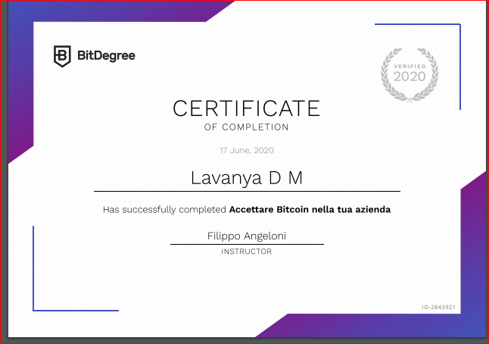

Coding Challenges Details: (Attach the snapshot and briefly write the report for the same)

**Problem 1:** Write a C Program to generate first N Magic Numbers

A magic number is defined as a number which can be expressed as a power of 5 or sum of unique powers of 5. First few magic numbers are 5, 25, 30(5 + 25), 125, 130(125 + 5), ….  
Input: n = 1  
Output: 5

Input: n = 2  
Output: 5 25

Input: n = 3  
Output: 5 25 30

Input: n = 8  
Output: 5 25 30 125 130 150 155 625

Hint:  
The magic numbers can be represented as 001, 010, 011, 100, 101, 110 etc, where 001 is 0*pow(5,3) + 0*pow(5,2) + 1*pow(5,1). So basically, we need to add powers of 5 for each bit set in given integer n.  
If n = 1; binary representation of 1 = 0001  
Magic Number is: 0 * pow(5,4) + 0 * pow(5, 3) + 0 * pow(5, 2) + 1 * pow(5, 1) = 5

If n = 6; Binary representation of 6 is 0110  
6th Magic Number is: 0 * pow(5, 4) + 1 * pow(5, 3) + 1 * pow(5, 2) + 0 * pow(5, 1)  
= 0 + 125 + 25 + 0 = 150

Logic:

Read n  
for(i = 0 to n)  
{  
Display ith magic number  
}

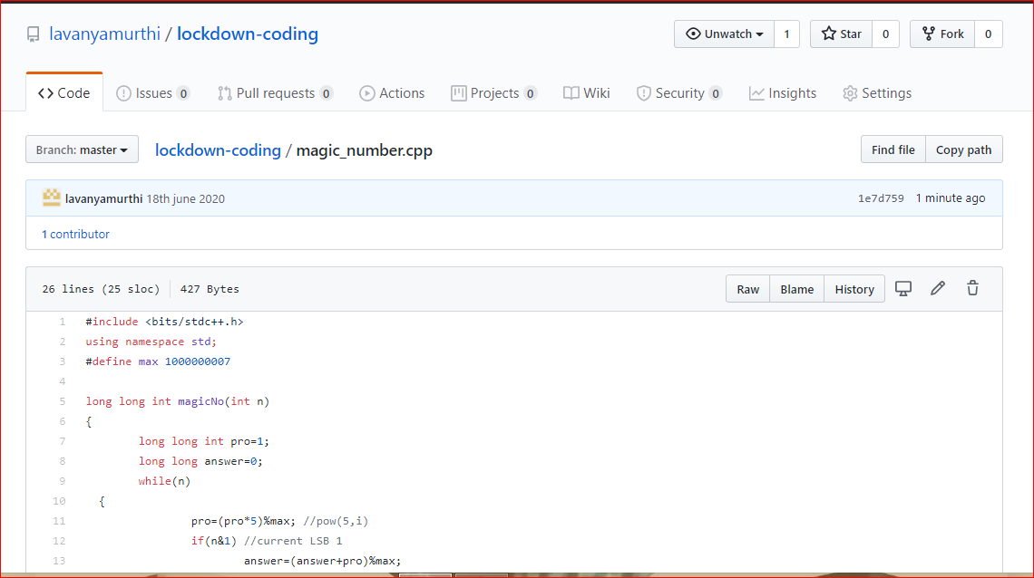

**Problem 2:** Find the smallest positive integer value that cannot be represented as sum of any subset of a given array sorted in ascending order

Given a sorted array (sorted in non-decreasing order) of positive numbers, find the smallest positive integer value that cannot be represented as sum of elements of any subset of given set  
Examples:

Input: arr[] = {1, 3, 6, 10, 11, 15};  
Output: 2  
There are no one or more elements to be added up to get sum = 2

Input: arr[] = {1, 1, 1, 1};  
Output: 5  
1 = 1, 1+1 = 2, 1+ 1 + 1 = 3, 1 + 1 + 1 + 1 = 4,  
There is no elements in the array to get sum 5

Input: arr[] = {1, 1, 3, 4};  
Output: 10  
1 = 1, 1 + 1 = 2, 3 = 3, 1 + 3 = 4, 1 + 4 = 5, 1 + 1 +4 = 6, 3 + 4 = 7........  
To get sum 10, there is no elements in the array.

Input: arr[] = {1, 2, 5, 10, 20, 40}  
Output: 4  
There are no elements to get sum = 4.

Input: arr[] = {1, 2, 3, 4, 5, 6}  
Output: 22

